International University

Report Project Final Web Application Development

**Vietnam National University, HCMC**

**International University – School of Computer Science & Engineering**

**Report Project Final**

**Course: Web Application Development**

*Student:*

**Tạ Thanh Vũ - ITITIU21352**

**Lê Quang Nguyên - ITITIU21265**

**Lê Ngô Gia Bảo - ITITIU21159**

December, 2025

Table of Contents

1 Introduction 2

1.1 Project Background 2

1.2 Programming Language 3

1.3 Framework, Database, and Tools 3

2 Requirement Analysis 3

2.1 Use Case Diagram 3

2.2 Functional Requirement & Non-functional 6

2.2.1 Functional Requirements 6

2.2.2 Non-Functional Requirements 9

3. Design and Implementation 12

3.1 Design 12

3.1.1 Model View Controller Model (MVC Model) 12

3.1.2 Relational Schema 13

3.1.3 Sequence Diagram 16

3.2 Implementation 22

4 Challenges 27

4.1 Database Synchronization 27

4.2 Insufficient Knowledge in Tools/Technologies 28

5 Conclusion 28

# 

# 1 Introduction

## 1.1 Project Background

The **Bookly** is a dynamic platform designed to connect readers with their favorite books. Users can explore various categories, view book details, and make purchases directly on the website. Features include account management, shopping cart functionality, and an admin dashboard for content and order management.

## 1.2 Programming Language

For this project, we selected **PHP (Hypertext Preprocessor)** as the core server-side scripting language.

**Why PHP?** PHP is widely used for web development due to its simplicity, efficiency, and strong support for database integration. It allows us to build dynamic web pages that interact seamlessly with the database.

**Version:** The project is compatible with PHP 8.1 (as indicated in the SQL dump header).

## 1.3 Framework, Database, and Tools

Instead of using a heavy framework like Spring Boot (as initially planned in previous drafts), we opted for **Native PHP** to demonstrate a solid understanding of fundamental web logic without relying on third-party abstractions.

**Database:** **MySQL** (via phpMyAdmin) is used for storing relational data such as users, products, and orders.

**Frontend Technologies:** HTML5, CSS3 (Custom styling in style.css), and JavaScript (script.js for frontend interactivity).

**XAMPP:** For local server environment (Apache + MySQL).

**Visual Studio Code:** For code editing.

**Git/GitHub:** For version control and collaboration.

# 2 Requirement Analysis

## 2.1 Use Case Diagram

This Use Case Diagram illustrates the functional requirements of a **BookStore** system, identifying the interactions between different types of users (Actors) and the system’s core features (Use Cases).

Figure 1: Usecase diagram of the system

**Actors**

The diagram identifies two primary **Actors** who interact with the system:

**Customer:** A front-end user who browses the store and makes purchases.

**Admin:** A back-end user responsible for managing the store's data and operations.

**System Boundary**

The large rectangle labeled **"BookStore"** represents the system boundary. It defines the scope of the application; everything inside the box is a functional requirement of the software, while the actors remain outside as external entities.

**Use Case Descriptions**

The ovals (or rounded rectangles) represent the specific actions or services the system provides:

Customer Actions:

**View Products:** Allows the customer to browse the inventory.

**Send Message:** Provides a way for the customer to contact support or the store owner.

**Add to Cart:** Allows the customer to select items for potential purchase.

**Place Order:** The final step in the purchasing process.

**Login:** A security feature to identify the user.

Admin Actions:

**Manage Products:** Adding, editing, or deleting books from the inventory.

**Manage Orders:** Reviewing, updating, or fulfilling customer orders.

**Login:** Accessing the administrative dashboard securely.

**Relationships and Logic**

The lines and arrows indicate how the actors interact with the functions:

**Associations:** The solid lines show which actor can perform which action. For example, both the Customer and the Admin have a direct relationship with the **Login** use case.

**Dependencies (Dashed Arrows):** The dashed lines pointing from **Add to Cart** and **Place Order** toward **Login** represent an **Include** or **Pre-requisite** relationship.

*Interpretation:* In this system, a customer can "View Products" without logging in, but they **must** log in to "Add to Cart" or "Place Order." This ensures that transactions are tied to a specific user account.

# 2.2 Functional Requirement & Non-functional

### 2.2.1 Functional Requirements

**1) Account Management**

* Supports user register / login / logout
* Uses session-based authentication to store user info (user ID, name, email)
* Admin pages are protected by an admin authentication gate (admin session)
* Provides an account dropdown for admins (view account + logout)
* Provides a header user box toggle for users (view session info + logout)

**2) Catalog Management**

Customers can view products:

* Homepage shows latest products (limited set)
* Shop page shows full product list
* Admin can manage products with full CRUD:
* Add / edit / delete products
* Upload product images
* Product images are served from an upload directory based on stored image paths

### 

**3) Shopping Cart and Order Management**

Users can add products to cart from product listing pages

Cart data is stored in a cart database table

Cart page supports: view cart items, update quantity, remove items, calculate subtotal and total

Checkout process supports: Calculate grand total, check duplicate orders, create order records in orders table, clear cart after successful ordering

Users can view their orders

Admin order management supports: View all orders, update order status, delete orders

**4) Notification System**

Uses flash messages for user/admin actions

Messages are displayed in the interface after key operations (e.g., add to cart, update, checkout)

Supports: Manuals dismiss (close icon) , Auto-dismiss after a short time

**5) Content Management**

Includes static/informational pages (e.g., About section)

Contact feature:

Users submit contact messages

Messages are stored in a message table

Admin can view and delete messages

System-wide footer provides consistent links/navigation

**6) Search and Navigation**

Responsive navigation for users:

Main navbar + user dropdown

Mobile menu toggle

Sticky header on scroll + close-on-scroll behavior

Admin navigation:

Admin navbar + account box toggle

Product search:

Search products by keyword

Display matching results on a search results pag**e**

### 2.2.2 Non-Functional Requirements

**1. System Performance**

Uses simple, direct mysql_query per request

No caching or pagination for shop and order pages, which may reduce performance with large datasets

Product images are served statically from the upload directory

No asset bundling, minification, or CDN usage except Font Awesome

JavaScript and CSS files are small and loaded separately

**2. User Experience**

Responsive toggles for navbar, user dropdown, and admin account box

Sticky header behavior during scrolling

Flash messages with auto-dismiss functionality

Mobile menu support for smaller screens

Forms rely mainly on basic HTML validation

No advanced client-side validation for checkout or contact forms

**3. Device & Browser Compatibility**

Uses modern ES6 JavaScript features (e.g., querySelector, classList, arrow functions, optional chaining)

Compatible with modern browsers

No polyfills for older browsers

Layout built with flexbox and simple CSS

UI interactions rely heavily on .active class toggling

**4. Future Growth**

No pagination or optimized search queries

Scaling product and order lists will require query limits, indexing, and pagination

No front-end build pipeline in place

Asset growth may require bundling and minification

Search functionality is basic

Advanced filtering or faceted search will require additional backend logic

**5. Data Security**

Session-based access control for users and admins

Database queries interpolate variables, even when escaped

No use of prepared statements, increasing security risk

No CSRF protection on forms

Password handling not evaluated in this scope

Product image uploads require file type and size validation

No rate limiting or CAPTCHA for login and contact forms

# 3. Design and Implementation

## 3.1 Design

### 3.1.1 Model View Controller Model (MVC Model)

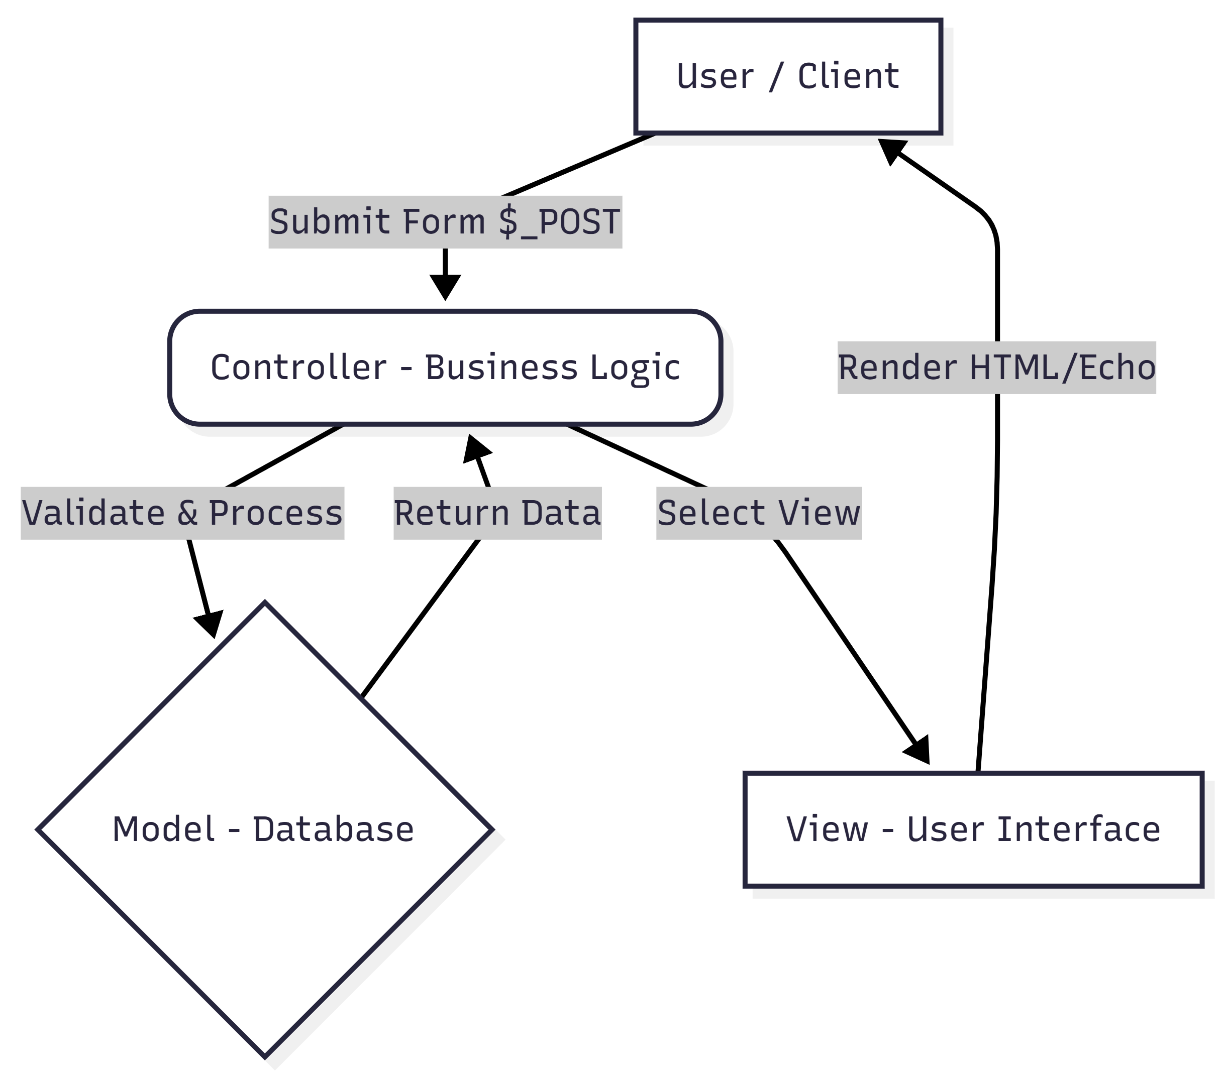

Figure 2: The Entity-Relationship Diagram of the project

Although the project is built with Native PHP, it follows a logical separation of concerns.

Such as the MVC architecture:

* **Model (Database & Logic):** Represented by the MySQL database (shop_db)

and the connection file **config.php**. It handles data structure and retrieval.

* **View (User Interface):** The HTML sections within files (e.g., **home.php**, **shop.php**)

act as the View.

* **Controller (Business Logic):** The PHP blocks at the top of each file act as Controllers.

They handle form submissions ($_POST), validate input, communicate with the database

and determine which View to render.

### 3.1.2 Relational Schema

Figure 3: The relational schema of the project

**Core Tables and Data Entities**

The schema consists of five primary tables, each serving a specific role in the e-commerce workflow:

* **Users:** The central hub of the database. It stores account details including names, emails, passwords, and a user_type (which likely distinguishes between the "Customer" and "Admin" roles seen in your use case diagram).
* **Products:** Contains the inventory data, storing the book name, price, and a reference to the image file.
* **Cart:** Acts as a bridge between users and products. It tracks which items a specific user has selected and the quantity of those items.
* **Orders:** Records finalized transactions. This table is data-heavy, capturing the customer's contact info, address, payment status, and a summary of the total_products purchased.
* **Message:** Stores communications sent by users, including their contact details and the specific message content.

**Relationships and Cardinality**

The dashed lines represent **Foreign Key** relationships, which maintain data integrity across the system:

One-to-Many (1:N) Relationships

Most connections here follow a "one-to-many" logic, indicated by the straight line on one side and the "crow's foot" (three-pronged fork) on the other:

* **Users to Orders:** One user can place multiple orders over time, but each order belongs to only one user.
* **Users to Cart:** One user can have multiple distinct items in their cart.
* **Users to Message:** One user can send multiple messages/inquiries to the store.
* **Products to Cart:** One product can be added to the shopping carts of many different users.

**Data Integrity and Keys**

**Primary Keys (Yellow Key Icon):** Each table has an id field. This is a unique identifier

that ensures no two rows in a table are identical.

**Foreign Keys (Red Diamond Icon):** Fields like user_id and product_id are used to

"point" to the primary key of another table. This allows the system to know exactly which user placed which order without duplicating all the user's personal info in the Orders table.

**Technical Specifications**

**Data Types:** The schema uses INT for whole numbers (like price or quantity) and VARCHAR for text (like names or addresses).

**Storage Limits:** For example, the address field allows up to **500 characters**, while the total_products field in the Orders table allows up to **1000 characters** to accommodate a long list of purchased items.

### 3.1.3 Sequence Diagram

#### 1. Register account

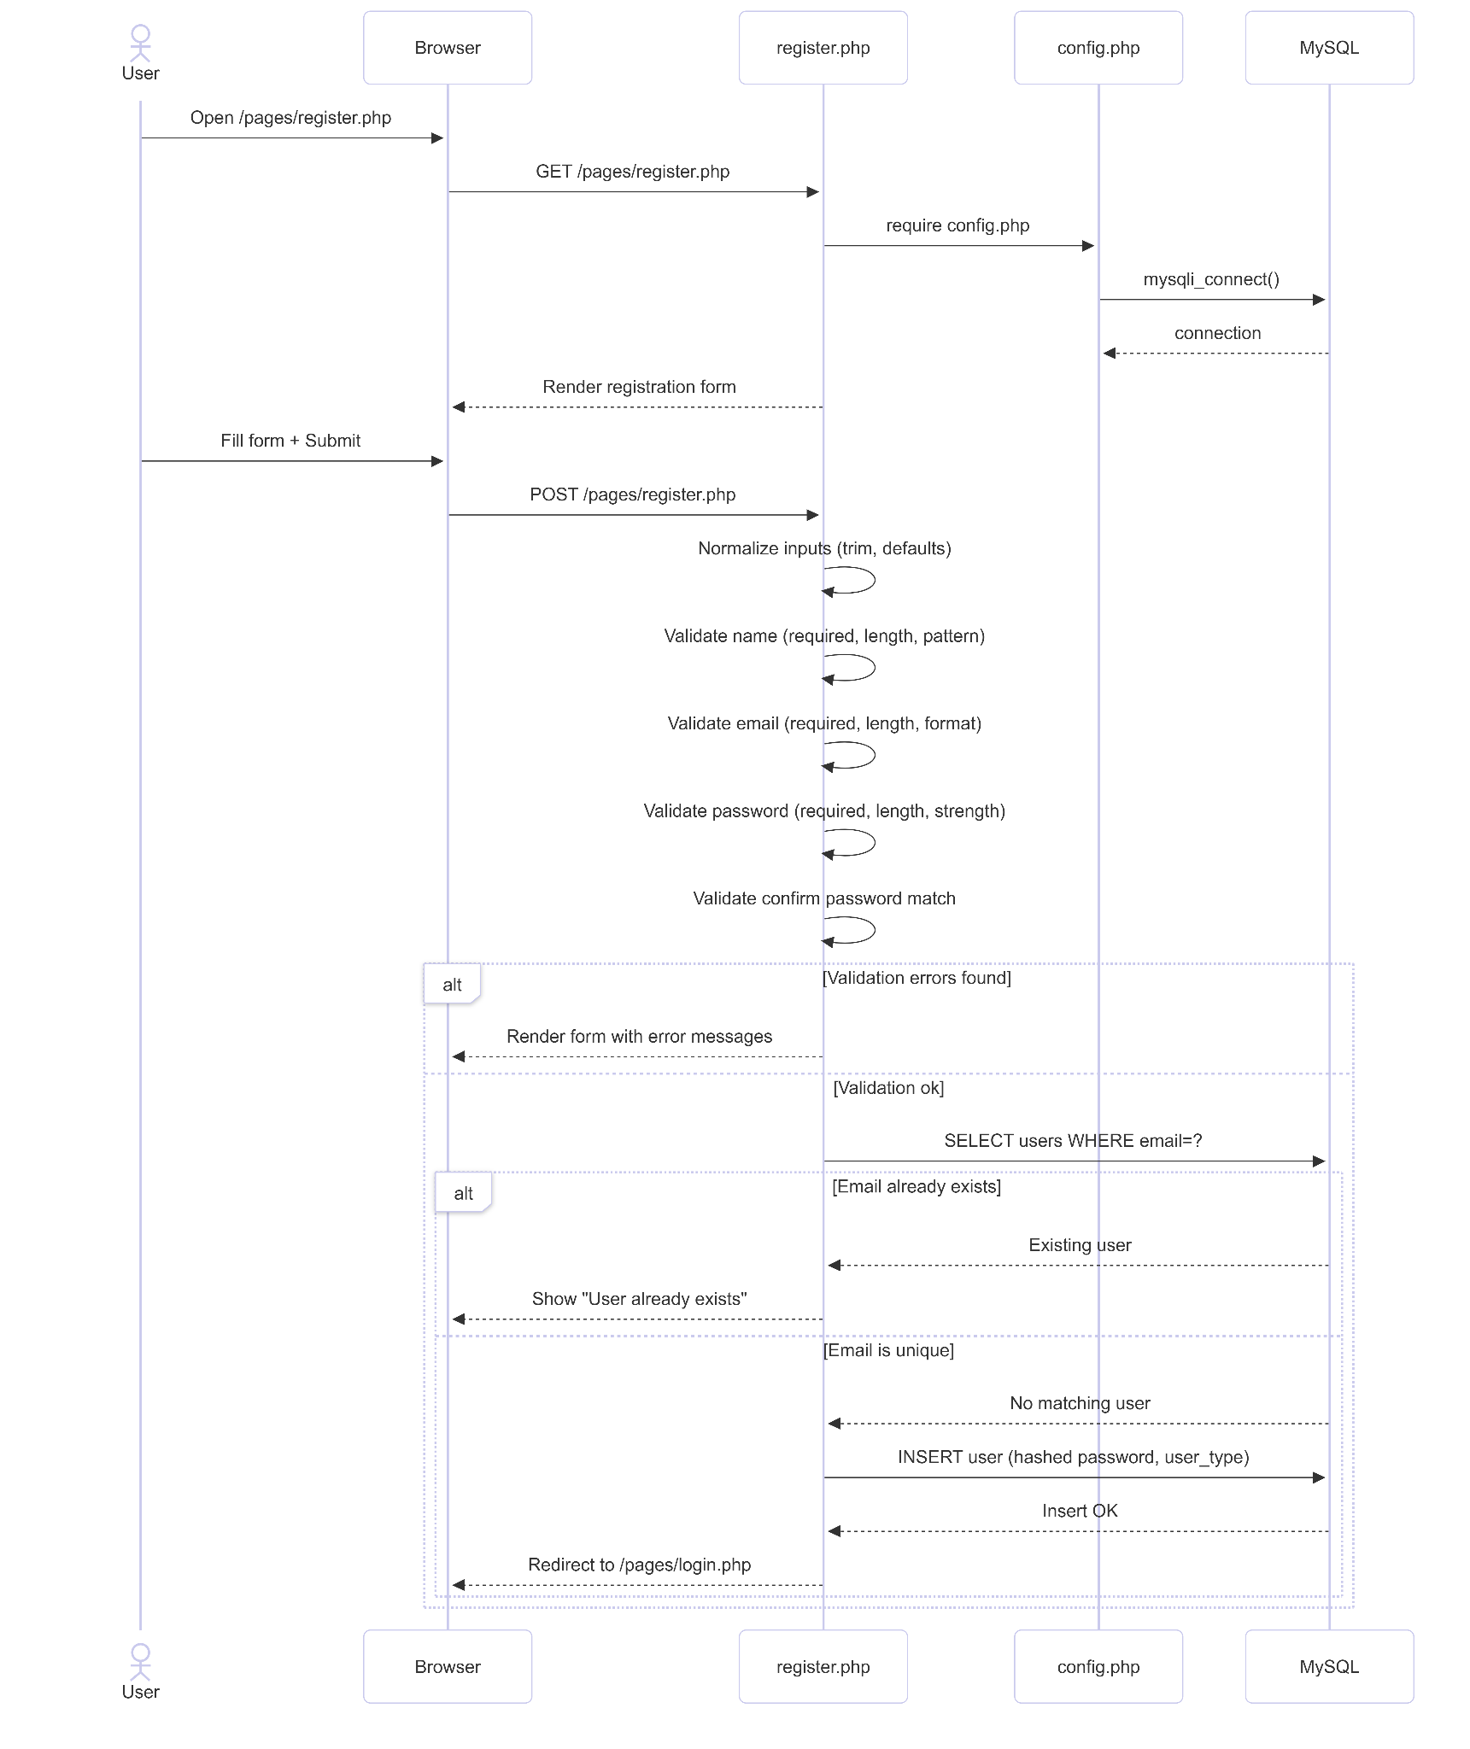

Figure 4: Sequence diagram for register account

The registration flow starts when a user submits the sign‑up form. The server normalizes and validates the name, email, password, and confirmation fields. If any validation fails, error messages are returned to the form. If validation passes, the system checks for an existing account by email. If the email is unique, it creates the user record and redirects to the login page; otherwise, it shows a “User already exists” message.

#### 2. Login Account

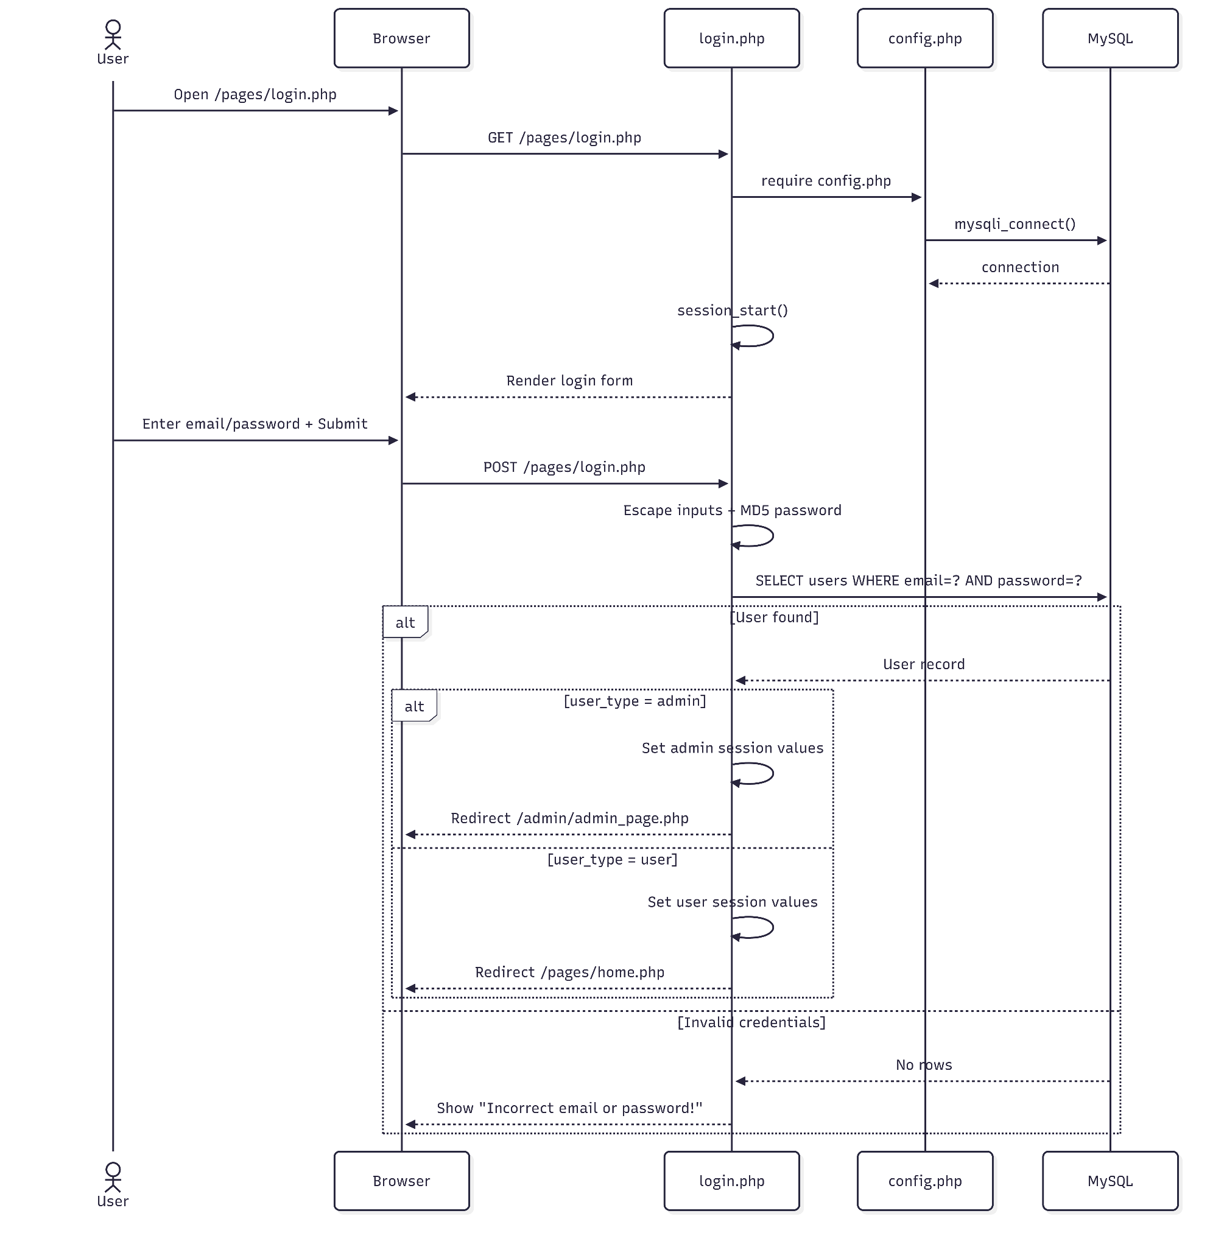

Figure 5: Sequence diagram for login account

The login flow begins when the user submits their email and password. The server hashes the password and queries the database for a matching user record. If a match is found, it starts a session, stores user data based on the role (admin or user), and redirects to the appropriate dashboard. If the credentials are invalid, the user is returned to the login page with an error message.

#### 3. Order book

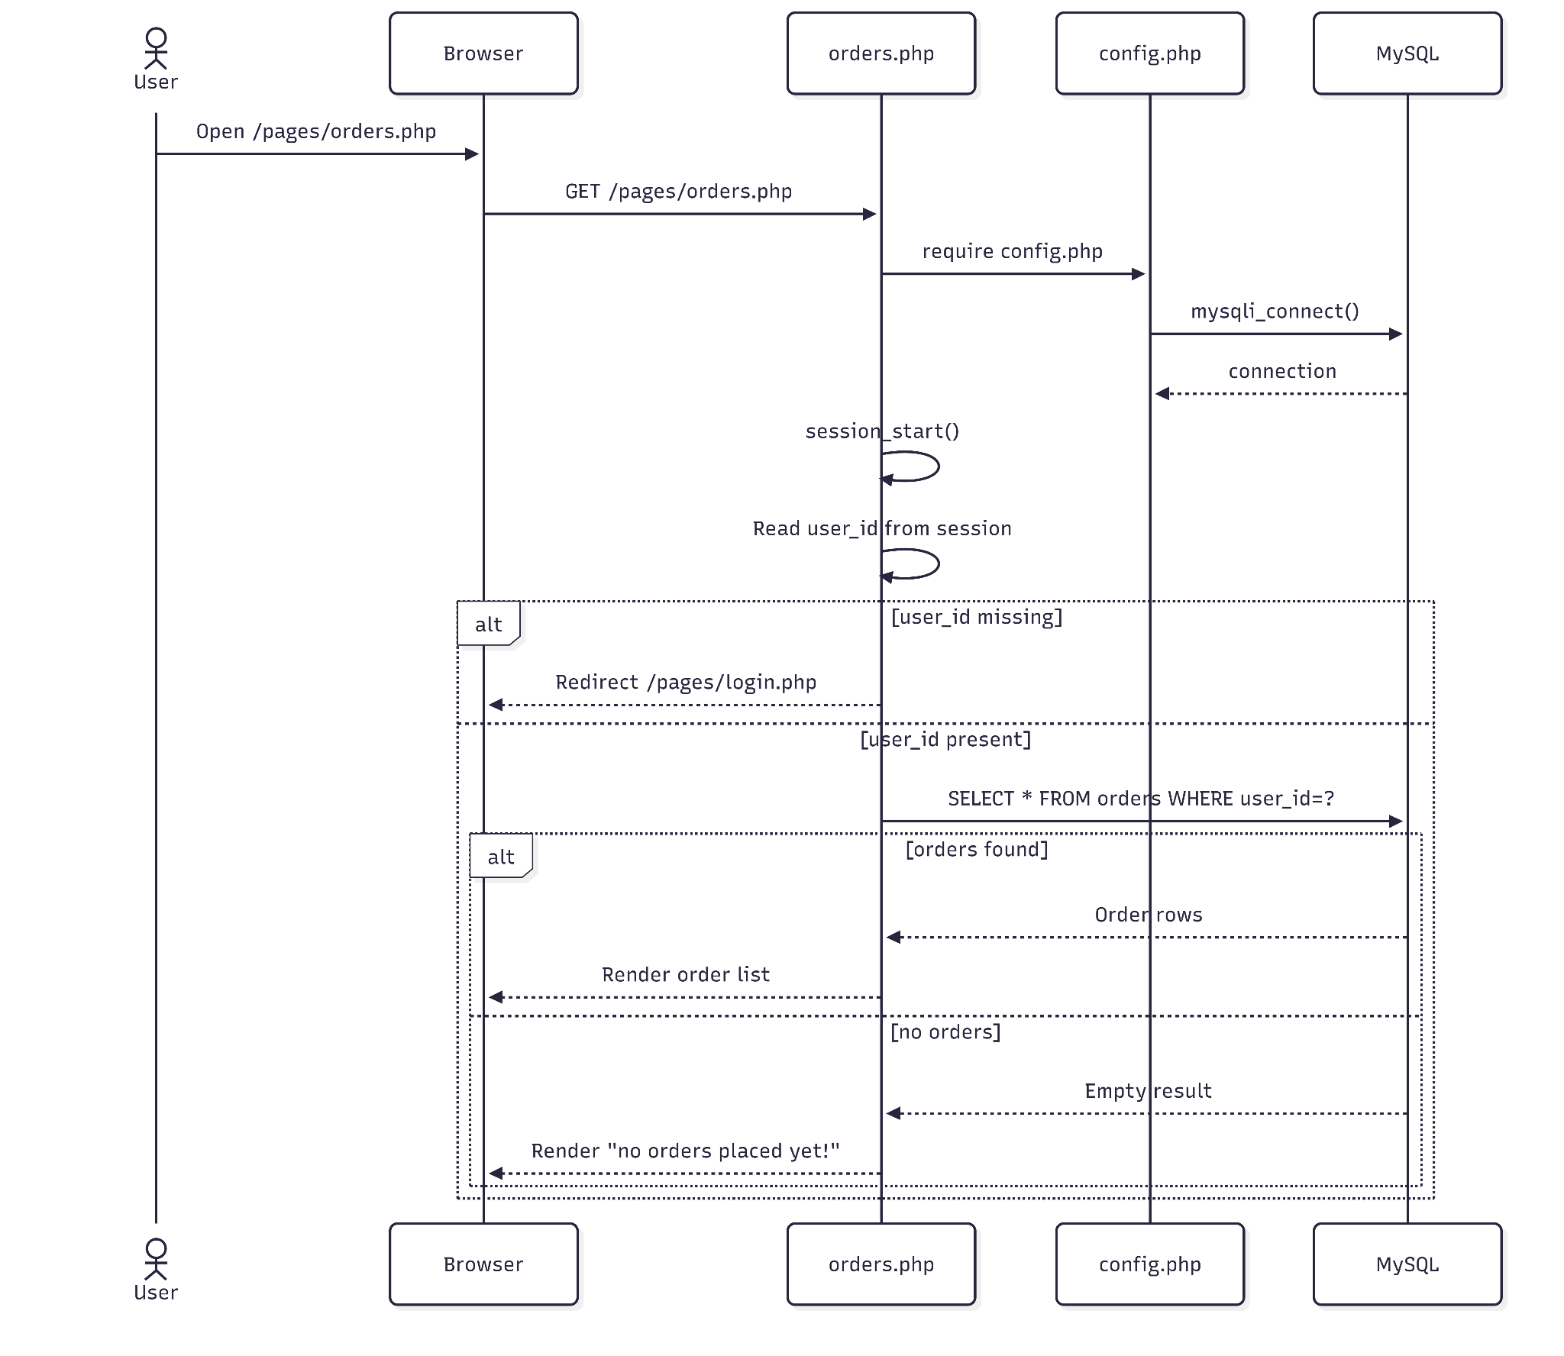

Figure 6: Sequence diagram for order book

The orders flow starts when a logged‑in user opens the orders page. The server checks the session for a valid user ID; if missing, it redirects to the login page. If authenticated, it queries the database for the user’s orders and renders either the order list or a “no orders placed yet” message.

#### 4. Purchase

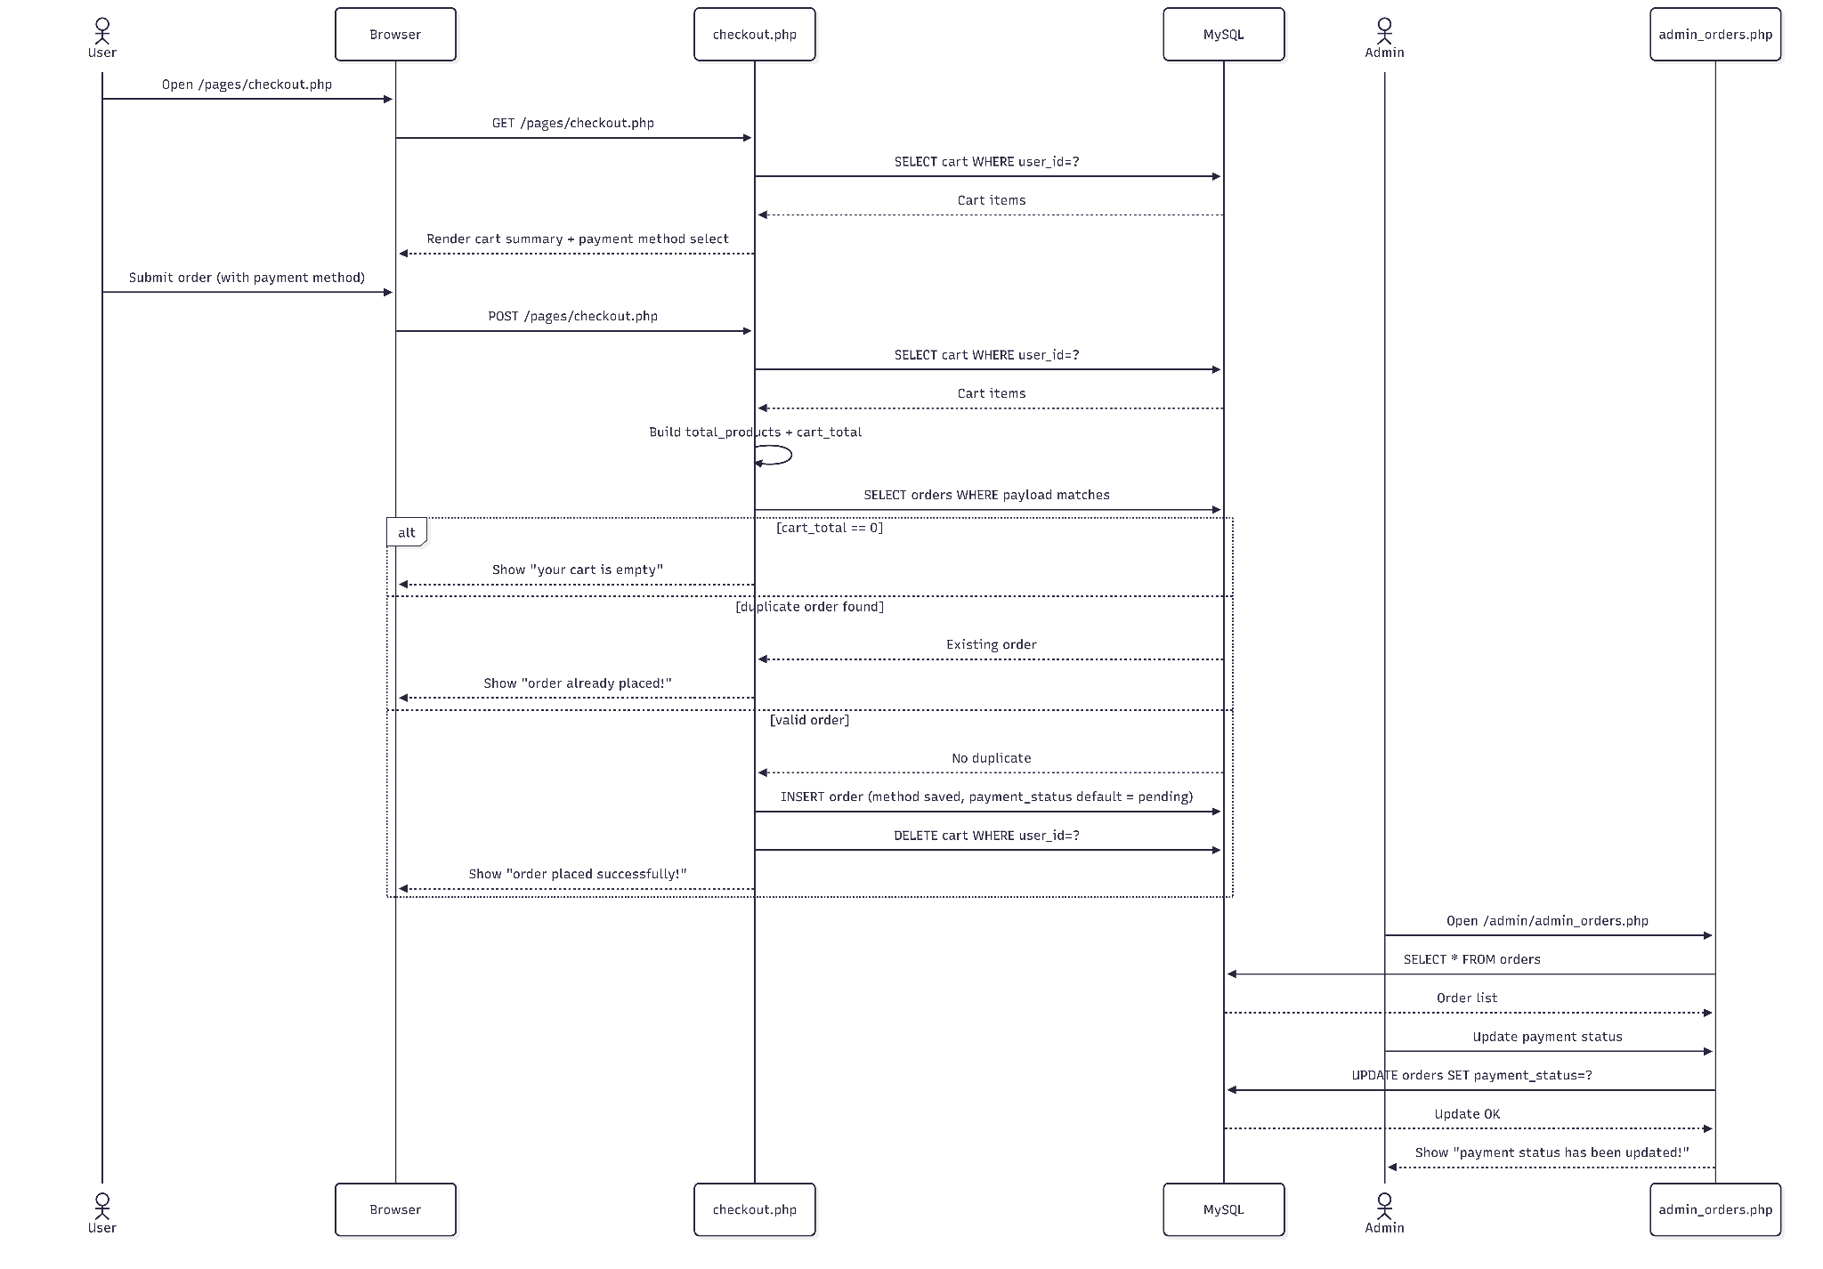

Figure 7: Sequence diagram for purchase

The payment flow is recorded during checkout. The user selects a payment method and submits the order. The server calculates cart totals, prevents duplicate submissions, and inserts a new order with the selected method and a default payment status of “pending,” then clears the cart. An admin can later update the payment status from the admin orders page.

#### 5. Shipping

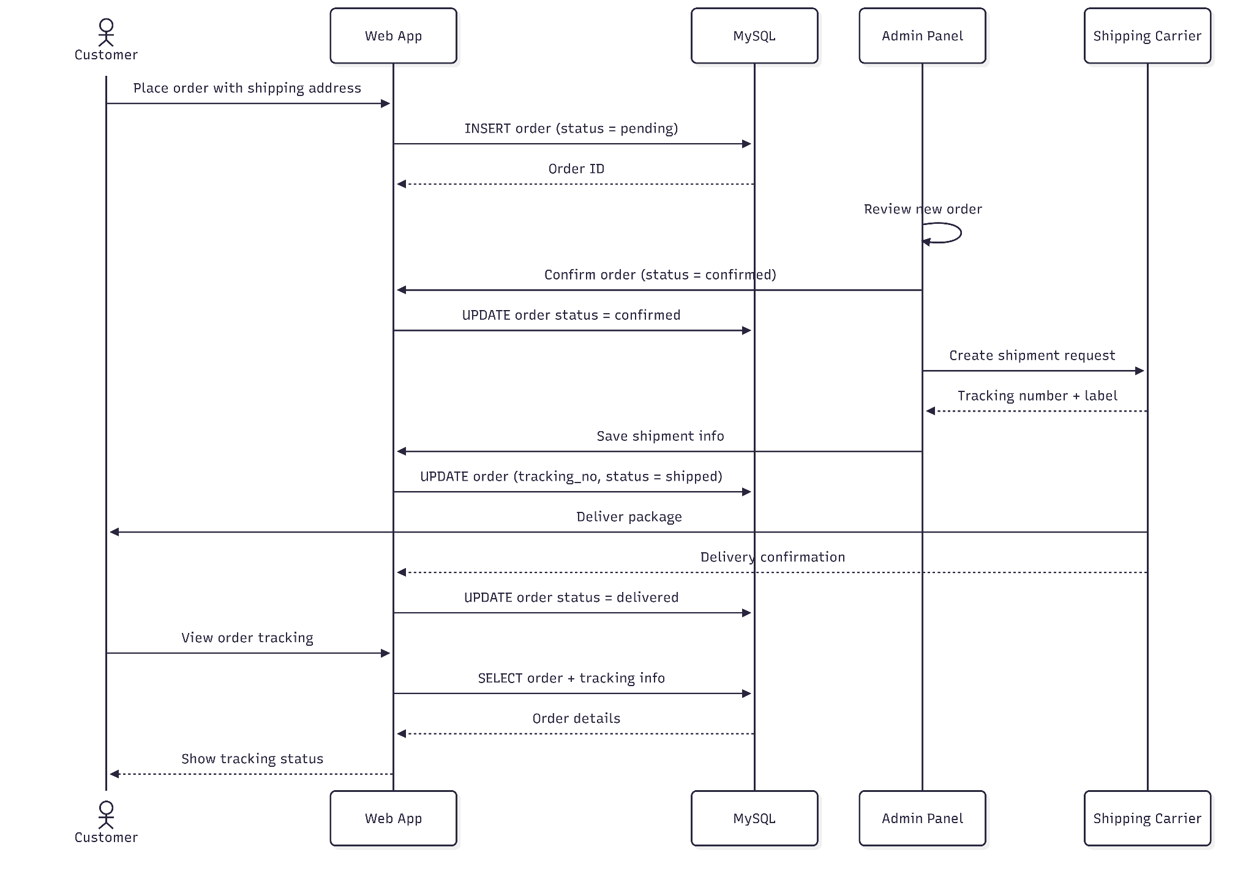

Figure 8: Sequence diagram for shipping

After an order is confirmed, the admin creates a shipment with a carrier and stores the tracking number. The order status moves from confirmed to shipped, and the customer can view tracking information. When the carrier confirms delivery, the system updates the order to delivered.

## 3.2 Implementation

#### Register account

Go to the homepage



Figure 13: Homepage website

Press button Login to create login account.

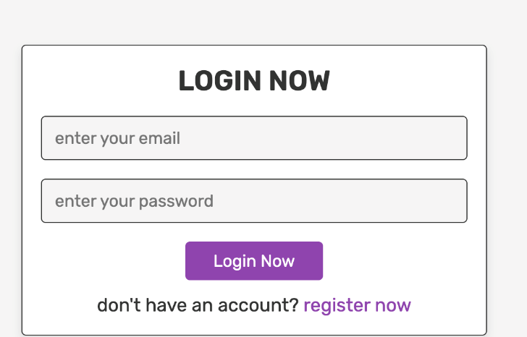

Figure 14: login page

Press creates new account if you didn’t have ones.

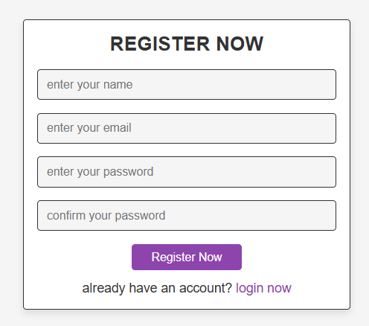

Figure 15: Create account

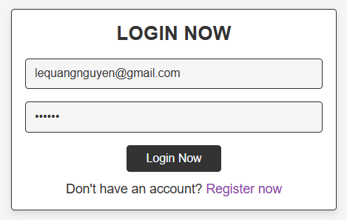

Figure 16: Login (check the box remember me to quick login for the later time)

After login website will bring us to the home page like this. There are many books type so you can click to find your favorite type of books



Figure 17: home page

After you click on those type, there are many things to sort like price, types, rating



Figure 18: page to find your books

After click on any books, website will bring you to this page to add to wishlist ( to buy later if have better price), add to cart (to buy now)

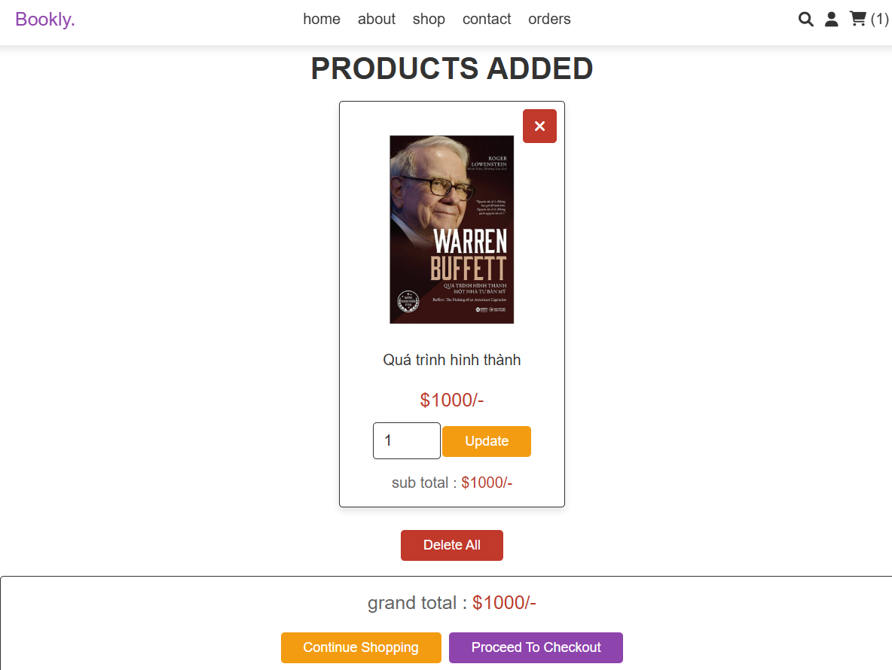

Figure 19: add to Wishlist or cart

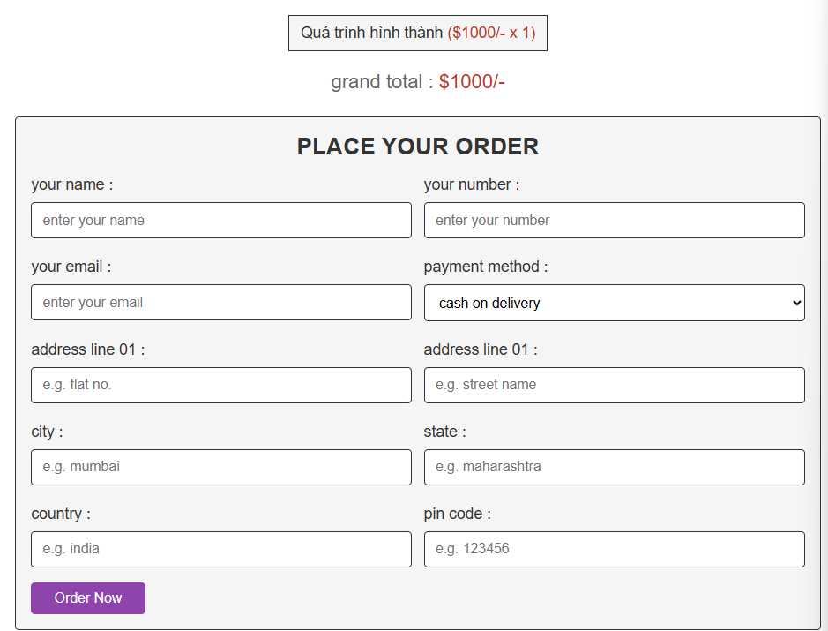

Firgure 20: checkout

# 4 Challenges

Below are some challenging problems commonly encountered by everyone working on the same project. We acknowledge these issues and aim to address them in more stable future projects.

## 4.1 Database Synchronization

* **Challenge**: Maintaining consistency in the database schema among team members.
* **Symptoms**: Inefficient management of database updates (e.g., adding tables, modifying fields) can lead to discrepancies between the database structure and the application code.

## 4.2 Insufficient Knowledge in Tools/Technologies

• **Challenge**: Team members may lack adequate knowledge of essential tools like MySQL, leading to challenges in writing efficient queries, designing appropriate schemas, or debugging database issues due to limited prior experience with database management or web development concepts.4.3 GitHub Version Control Conflicts

* Challenge: When multiple people work on the same files, conflicts arise when merging code because of lacking experience with Git workflows (e.g., branching, committing, resolving

conflicts).

* Symptoms: Must resolve conflict when occurring.

# 5 Conclusion

Through the development of **BookStore**, our team has successfully built a functional

e-commerce web application.

* **Achievements:** We implemented full CRUD (Create, Read, Update, Delete) operations

for products and orders, a secure authentication system, and a dynamic shopping cart.

* **Knowledge Gained:** We deepened our understanding of **PHP server-side logic**,

**MySQL relational database design**, and how to effectively bridge the frontend and

backend without relying on heavy frameworks.

* **Future Work:** In the future, we plan to integrate a real payment gateway

(like Stripe or PayPal API) instead of just simulating "Credit Card" status, and implement

an email notification system for order confirmations.